Azure Component Diagram of Scheduling Framework & Public Timetable

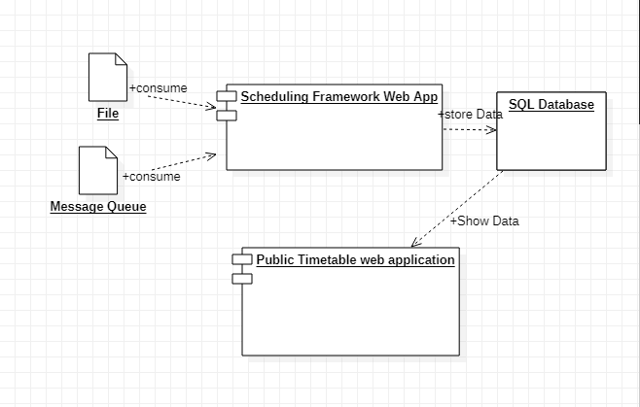

Assumptions: -

1. The Scheduling Tool REST API returns a flat .txt file with one entry per line. Scheduling Framework will consume that flat .txt file and storing it in sql database.
2. Message Queue data is consumed by application and data will be store in sql database.
3. Public time table web application will show SQL Database data which was store by scheduling framework.